



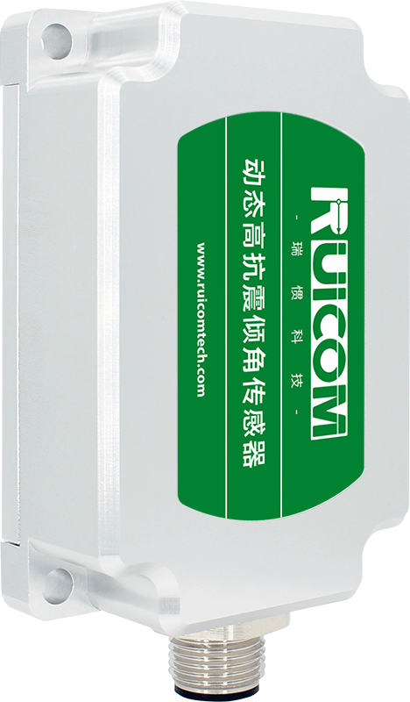

DTS CAN2.0A/B Dynamic High-Shock-Resistant Tilt Sensor

Product Manual

V1.0-20250226



Product Introduction
The DTS CAN2.0 A/B is a high-precision digital dynamic tilt sensor developed by RUICOM Technology based on advanced MEMS technology. It is specifically designed for real-time attitude monitoring of moving vehicles, accurately measuring roll, pitch, and azimuth angles, and is particularly suitable for attitude analysis in highly dynamic or strong vibration environments. This product adopts a dual CAN bus architecture (supporting CAN2.0A/CAN2.0B protocols), possessing excellent system compatibility and scalability.
Its core features include:
1) Multi-axis inertial measurement unit: Integrating a high-precision three-axis accelerometer and gyroscope, combined with an adaptive Kalman filter algorithm, to achieve real-time attitude calculation under motion conditions.
2) Dynamic compensation technology: Built-in high-resolution AD and six-axis IMU, real-time correction of nonlinear errors, axial coupling, temperature drift, and rotational centrifugal force interference, effectively suppressing the influence of motion acceleration on the measurement and ensuring dynamic accuracy.
3) Industrial-grade reliability: Supports wide operating temperature range of -40℃ to +85℃, with high shock resistance, high vibration resistance, and anti-interference capabilities, suitable for harsh industrial scenarios such as engineering machinery and special vehicles.
Its technical advantages include:
- Non-contact measurement: No mechanical calibration required, easy installation, and direct output of digital attitude data.
- Dual CAN redundancy design: Enhances system compatibility and supports multi-node networking requirements in industrial automation.
3) Dual-mode output (static and dynamic): Balances high static stability with high dynamic responsiveness, adapting to complex working conditions: high-precision industrial automation fields such as engineering machinery leveling, AGV navigation, ship attitude control, and aerospace attitude measurement.

Key Features
★ Measuring Range (R±180°, P±90°, Y±180°) ★ Dynamic Accuracy ±0.1°
★ Static Accuracy ±0.05° ★ CAN2.0A/B Optional

★ Three Protection Classes Available
Main applications
★ High-impact vibration crushing equipment
★ Engineering vehicle equipment monitoring and control
★ Construction equipment leveling
★ Agricultural machinery monitoring and control
★ Aircraft attitude control
★ Ship attitude monitoring


Performance Parameters
DTS CAN2.0 A/B |  | Unit | Parameter
Measurement Range (Initial value after power failure is 0°) |  | ° | Roll ±180°, Pitch ±90°, Azimuth ±180°
Measurement Axis |  | axis | X-axis / Y-axis / Z-axis
Roll and Pitch Resolution^{1）} |  | ° | 0.01
Roll and Pitch Static Accuracy @25°C |  | ° | ±0.05
Roll and Pitch Dynamic Accuracy (rms) @25°C |  | ° | ±0.1
gyroscope | Gyroscope Range | °/s | ±300
gyroscope | Oblique Stability (10s Mean) | °/h | 8.5
gyroscope | Oblique Instability (allan) | °/h | 4.5
gyroscope | Angle Random Walk Coefficient (allan) | °/sqrt(h) | 0.25
acceleration | Acceleration Range | g | ±4 / ±16（optional）
acceleration | Oblique Stability (10s Mean) | mg | 0.02
acceleration | Oblique Instability (allan) | mg | 0.005
acceleration | Velocity Random Walk Coefficient (allan) | m/s/sqrt(h) | 0.005
Zero-point temperature coefficient^{3）}@-40～85℃ |  | °/℃ | ±0.01
Sensitivity temperature coefficient^{4）}@-40～85℃ |  | ppm/℃ | ≤100
Power-on time |  | S | ≤3.5
Response time |  | S | 0.01
Communication protocol |  | - | CAN2.0A/CAN2.0B
Electromagnetic compatibility |  | - | According to EN61000 and GBT17626
Mean time between failures (MTBF) |  | hour/time | ≥98000
Insulation resistance |  | megaohm | ≥100
Shock resistance |  | - | 100g@11ms, triaxial (half-sine wave)
Vibration resistance |  | - | 10grms、10～1000Hz
Protection class |  | - | IP67 / IP68（optional）
Weight |  | g | Single connector ≤165g (excluding cable) / Dual connector ≤180g (excluding cable)
1) Resolution: The smallest angular change that the sensor can detect within its effective range, reflecting its ability to monitor minute tilt fluctuations.
2) Accuracy: Calculated by performing multiple repeated measurements (sample size ≥ 16) at a fixed angle under standard ambient temperature (25±5℃), representing the root mean square (RMS) error between the measured and true values, characterizing the sensor's overall measurement deviation.
3) Zero-point temperature coefficient: The ratio of the sensor's output value to temperature change under zero-input conditions, defined as the ratio of the zero-point offset within the rated operating temperature range to the room temperature reference value.
4) Sensitivity temperature coefficient: The stability index of the sensor's full-scale output value with temperature changes, characterizing the drift rate of sensitivity relative to the room temperature reference value within the rated temperature range.


Electrical Parameters
Parameter | Condition | Minimum Value | Typical Value |  | Maximum Value | Unit
Power supply voltage | Standard | 9 | 12 | 24 | 36 | V
Operating current | No load |  | 40mA(12V) |  |  | mA
Operating temperature |  | -40 |  |  | +85 | ℃
Storage temperature |  | -40 |  |  | +85 | ℃


Ordering Information
Model | Package | - | Communication Protocol | - | Installation Orientation | Application | - | Protection Level | Connector
DTS | 3:PCBA Board | - | C2:CAN2.0A | - | H:Horizontal installation | OB:Marine Applications | - | 7:IP67 | S:Single head (male)
DTS | 6:Standard casing | - | C3:CAN2.0B | - | HD:Horizontal downwards | EV:Engineering Excavators | - | 8:IP68 | D:Double head (male/female)
DTS | 9:Corrosion-resistant casing | - |  | - | V:Vertical installation | EGP:Engineering Rock Piling | -
DTS |  | - |  | - | VL:Vertical leftwards | V:Vehicle Applications | -
DTS |  | - |  | - | VR:Vertical rightwards | MTI:Mine Car Slope | -
Example：DTS6-C2-HOB-7S：Standard housing / CANO 2.0A communication protocol / horizontal mounting / marine application / IP67 protection / single connector.

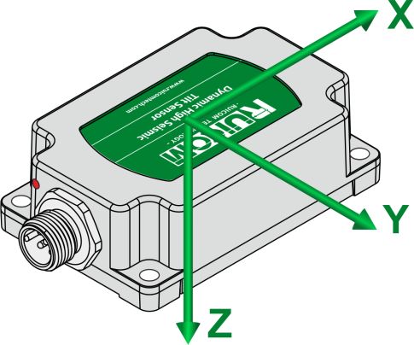
Install axial
The DTS series products adopt the ENU (East-North-Up) coordinate system and follow the right-hand rule. Attitude angles are defined according to the rotation order of Z / X / Y. When the positive Y-axis points in the direction of the vehicle's forward movement: the angle of rotation around the Z-axis is called the heading angle, the angle of rotation around the X-axis is called the pitch angle, and the angle of rotation around the Y-axis is called the roll angle.

Interface Definition
Pin/Thread Color | Definition | Description
PIN1 / Brown | PE | Protective ground
PIN2 / White | 9~36V | Positive power supply
PIN3 / Blue | GND | Negative power supply
PIN4 / Black | CAN_H | -
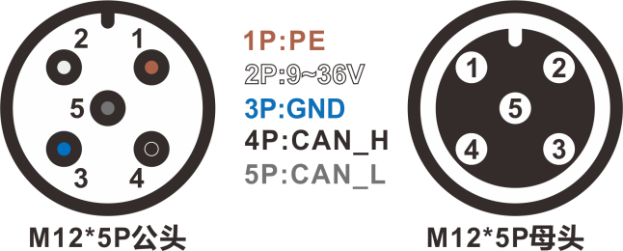  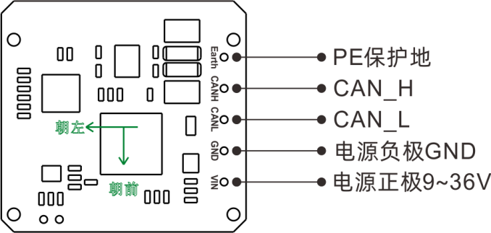  PIN5 / Gray  PCBA board wiring definition diagram  Connector pin definition diagram | CAN_L | -


Product Dimensions

PCBA Dimension Diagram
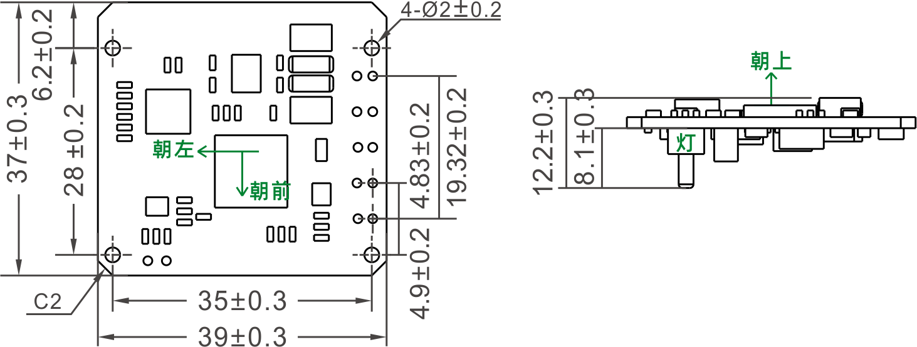
Single panel dimensions: L39×W37×H12.2mm
Installation dimensions: L35×W28mm

Single-head (male) connector housing dimension drawing
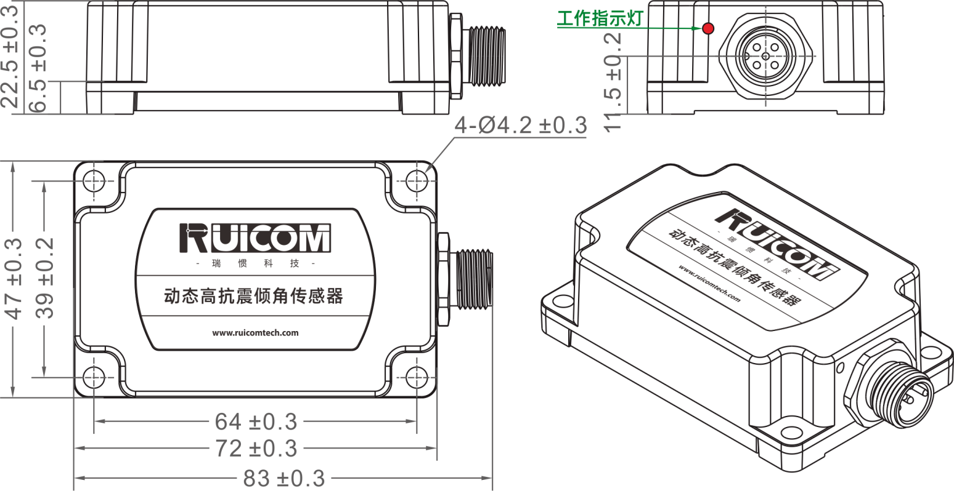

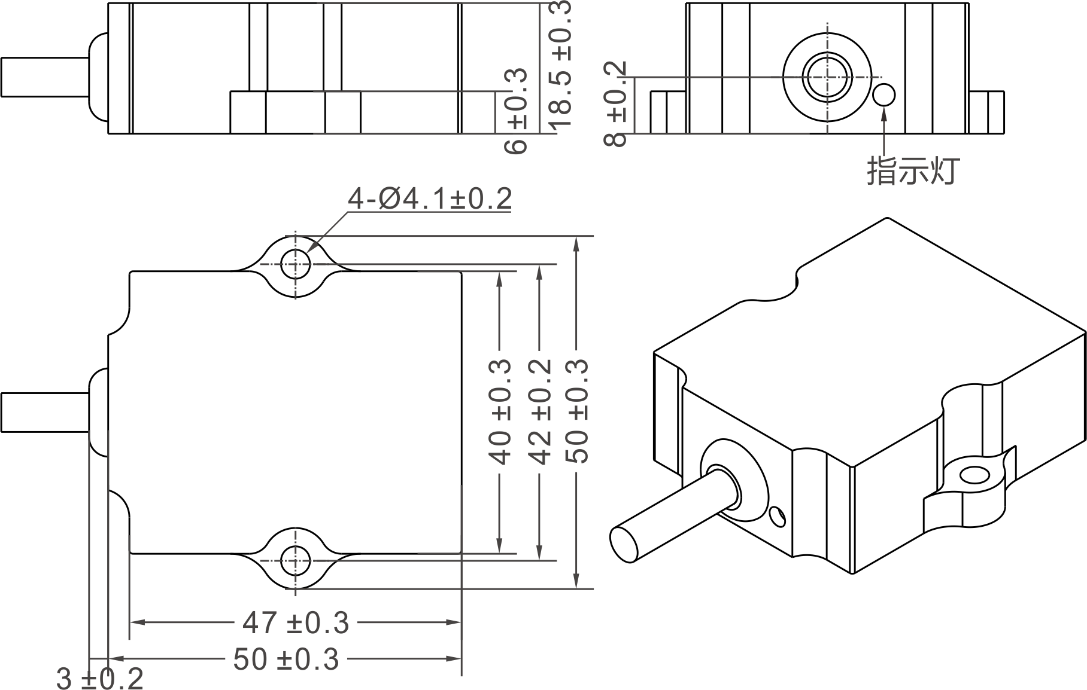

Case dimensions: L83×W47×H22.5mm
Recommended screws: 4 M5 screws

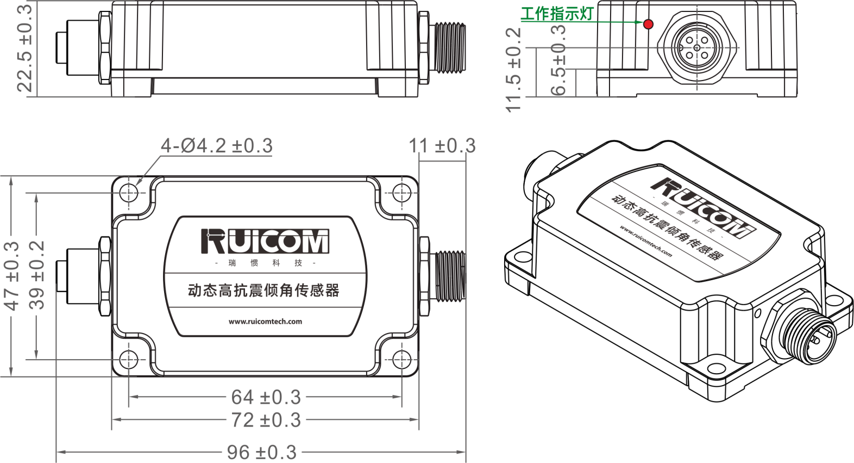
Dual-head (male and female) connector housing dimension diagram
Case dimensions: L96×W47×H22.5mm
Recommended screws: 4 M5 screws

Corrosion-resistant shell size diagram
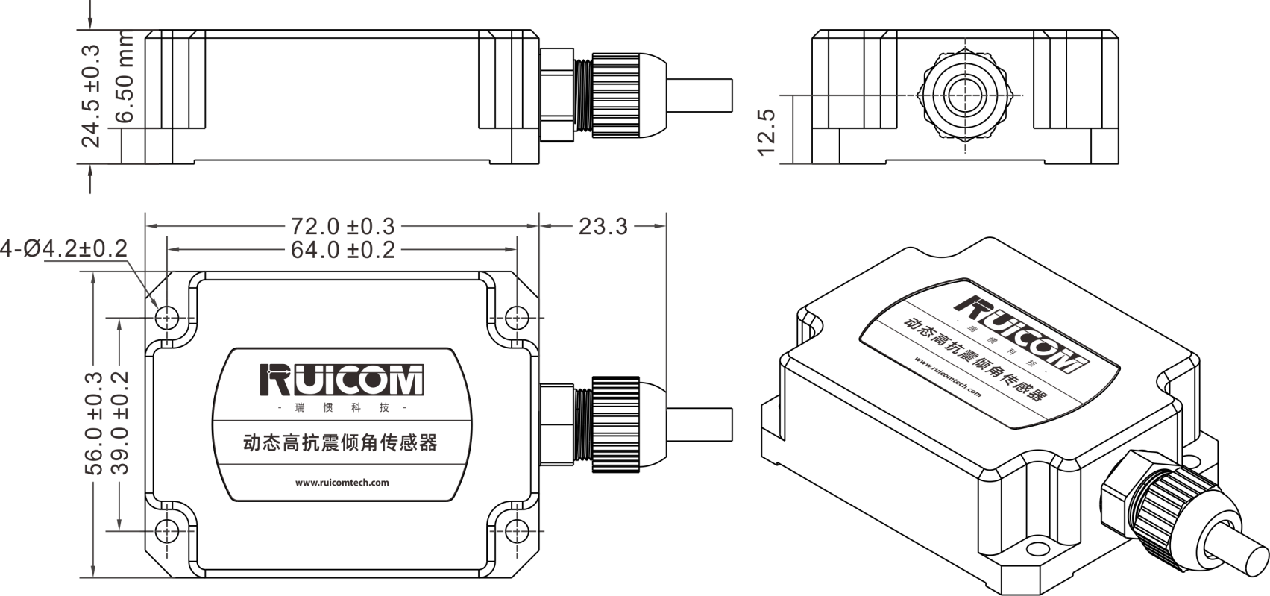
Case dimensions: L95.3×W56×H24.5mm
Recommended screws: 4 M5 screws


Measurement direction
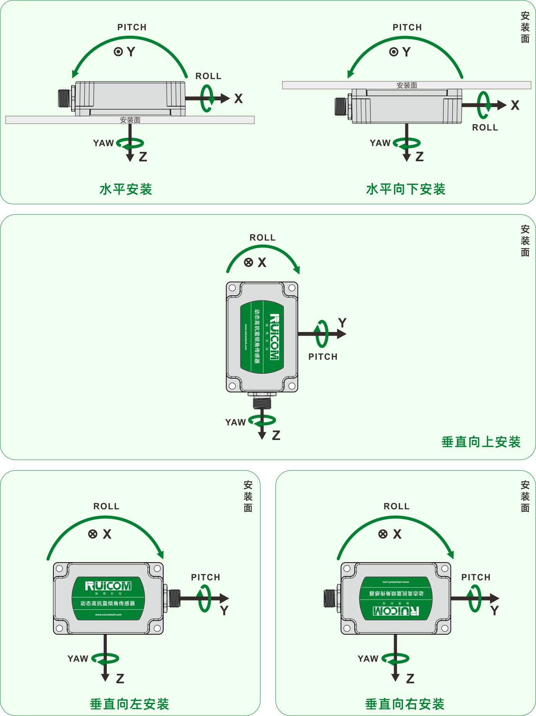
Install vertically upwards
Install vertically to the left
Install vertically to the right
Install horizontally downwards
Horizontal installation


Communication frame format
The CAN 2.0 protocol supports 2.0A (11-bit ID) or 2.0B (29-bit ID).
- Modify the node number (node range: 0x01-0x7F), the default node number is 0x05
Request message format
CAN-ID | First byte | Second byte | Third byte | Fourth byte | Fifth byte | Sixth byte | Seventh byte | Eighth byte
0x600+0x05 | 0x40 | 0x10 | 0x10 | 0x00 | Node_ID | 0x00 | 0x00 | 0x00
Response message format
CAN-ID | First byte | Second byte | Third byte | Fourth byte | Fifth byte | Sixth byte | Seventh byte | Eighth byte
0x580+0x05 | 0x40 | 0x10 | 0x10 | 0x00 | Node_ID | 0x00 | 0x00 | 0x00
Note: If the controller sends CAN-ID=0x600+0x05, the transmitted data is: 40 10 10 00 10 00 00 00. The sensor returns CAN-ID=0x580+0x05, and the returned data is: 40 10 10 00 10 00 00 00. After power-on, a frame ID of 0x590 (0x580+0x10) is received, indicating that the frame ID modification was successful.
- Set CAN Baud Rate
Request Message Format
CAN-ID | First byte | Second byte | Third byte | Fourth byte | Fifth byte | Sixth byte | Seventh byte | Eighth byte
0x600+0x05 | 0x40 | 0x20 | 0x10 | 0x00 | Baud | 0x00 | 0x00 | 0x00
Response message format
CAN-ID | First byte | Second byte | Third byte | Fourth byte | Fifth byte | Sixth byte | Seventh byte | Eighth byte
0x580+0x05 | 0x40 | 0x20 | 0x10 | 0x00 | Baud | 0x00 | 0x00 | 0x00
Note: The fifth byte (Baud) is 0x00, 0x01, 0x02, 0x03, or 0x04.
Where 0x00 represents setting the baud rate to 1000K bps, 0x01 represents setting the baud rate to 500K bps,
0x02 represents setting the baud rate to 250K bps, 0x03 represents setting the baud rate to 125K bps,
0x04 represents setting the baud rate to 100K bps.
The default baud rate is 125K bps. After sending this command and receiving the returned data, the sensor needs to be powered on again for the baud rate modification to succeed.
- Set Automatic Output Cycle Time (Factory Default Output Cycle 100ms)
Request Message Format
CAN-ID | First byte | Second byte | Third byte | Fourth byte | Fifth byte | Sixth byte | Seventh byte | Eighth byte
0x600+0x05 | 0x22 | 0x00 | 0x22 | 0x00 | T_L | T_H | 0x00 | 0x00
Response message format
CAN-ID | First byte | Second byte | Third byte | Fourth byte | Fifth byte | Sixth byte | Seventh byte | Eighth byte
0x580+0x05 | 0x22 | 0x00 | 0x22 | 0x00 | T_L | T_H | 0x00 | 0x00
The fifth and sixth bytes represent the time, with the fifth byte being the low byte and the sixth byte the high byte. The time range is 10ms to 1000ms.
For example: 10ms TIME_L=0x0A, TIME_H=0x00,
100ms TIME_L=0x64, TIME_H=0x00,
1000ms TIME_L=0xE8, TIME_H=0x03.
The settable range is 10ms to 1000ms, with a factory default of 100ms.
- Set the output frame type (factory default is angle frame)
Request message format
CAN-ID | First byte | Second byte | Third byte | Fourth byte | Fifth byte | Sixth byte | Seventh byte | Eighth byte
0x600+0x05 | 0x40 | 0x30 | 0x10 | 0x00 | MASK | 0x00 | 0x00 | 0x00
Response message format
CAN-ID | First byte | Second byte | Third byte | Fourth byte | Fifth byte | Sixth byte | Seventh byte | Eighth byte
0x580+0x05 | 0x40 | 0x30 | 0x10 | 0x00 | MASK | 0x00 | 0x00 | 0x00
The lower 3 bits of the fifth byte, Mask, are valid. Mask (binary: 0B00000cba).
a: Indicates an angle frame, 1: output on, 0: output off.
b: Indicates an acceleration frame, 1: output on, 0: output off.
c: Indicates a gyro angular velocity frame, 1: output on, 0: output off.
The host sends: 40 30 10 00 07 00 00 00, which will enable the output of angle, acceleration, and gyro angular velocity frames.
The host sends: 40 30 10 00 05 00 00 00, which will enable the output of angle and gyro angular velocity frames and disable the output of acceleration frames.
- Azimuth angle zeroing
Request message format
CAN-ID | First byte | Second byte | Third byte | Fourth byte | Fifth byte | Sixth byte | Seventh byte | Eighth byte
0x600+0x05 | 0x40 | 0x10 | 0x10 | 0x00 | 0x10 | 0x10 | 0x10 | 0x10
Response message format
CAN-ID | First byte | Second byte | Third byte | Fourth byte | Fifth byte | Sixth byte | Seventh byte | Eighth byte
0x580+0x05 | 0x40 | 0x10 | 0x10 | 0x00 | 0x10 | 0x10 | 0x10 | 0x10
Reset the current azimuth angle to zero.
- Data Parsing
1. There are three types of data frames: angle frames, acceleration frames, and gyroscope frames.
CAN-ID | First byte | Second byte | Third byte | Fourth byte | Fifth byte | Sixth byte | Seventh byte | Eighth byte
0x580+Node_ID | Data0 | Data1 | Data2 | Data3 | Data4 | Data5 | Data6 | flag
Data0-Data6: Represents data, the type (angle, acceleration, or gyroscope frame) is determined by the corresponding flag bit.
flag (ddddccaa): Unsigned single byte, 8 bits, representing the data frame type and installation measurement method:
aa: Indicates the data type of the frame
00: Indicates an angle frame (roll ±180°, pitch ±90°, azimuth ±180°);
01: Indicates acceleration (±32.765g);
10: Indicates gyroscope (±327.65°/s);
cc: Indicates the power-on self-test result:
00: Self-test successful;
01: Acceleration self-test failed;
10: Gyroscope self-test failed;
11: Both acceleration and gyroscope self-tests failed;
dddd: Indicates the installation test method (refer to the measurement installation method diagram for details):
0000: Horizontal installation measurement method.
0001: Vertical upward installation measurement method.
0010: Indicates a measurement method with the measurement facing vertically to the left (or laterally to the left).
0011: Indicates a measurement method with the measurement facing vertically to the right (or laterally to the right).
0100: Indicates a measurement method with the measurement facing horizontally downwards.
The following is a parsing of different data type frames for horizontal measurement methods:
A： Angle data frame
CAN-ID | First byte | Second byte | Third byte | Fourth byte | Fifth byte | Sixth byte | Seventh byte | Eighth byte
0x580+Node_ID | XL | XH | YL | YH | ZL | ZH | Temp | 0x00
The CAN-ID is followed by eight bytes of data. The first two bytes, XL and XH, represent the X-axis (ROLL) roll angle. The third and fourth bytes, YL and YH, represent the Y-axis (PITCH) tilt angle. The fifth and sixth bytes, ZL and ZH, represent the Z-axis (YAW) azimuth angle. The angle value is an int16_t, with the low byte first and the high byte last. Dividing by 100 yields the floating-point angle. The seventh byte is the temperature value, a signed single-byte integer.

Angle conversion example: 26 15 DA EA 28 23 19 00
Flag = 0x00 indicates a horizontal installation measurement method, and the data is in angle.
The X-axis roll angle data is represented by a 16-bit signed binary number, with the high 8 bits being XH and the low 8 bits being XL.
Convert this 16-bit signed binary number to a decimal number, then divide by 100 to obtain the angle.
For example: XL=0x26, XH=0x15, the angle is 54.14°
XH XL
0x15 0x26
0x1526( 5414 )
The final result is: 5414/100=54.14°

YH YL
0xEA 0xDA
0xEADA( -5414 )
The final result is: -5414/100=-54.14°

ZH ZL
0x23 0x28
0x2328( 9000 )
The final result is: 9000/100=90.00°

Temp
0x19(25) = 25℃.

B： Acceleration data frames
CAN-ID | First byte | Second byte | Third byte | Fourth byte | Fifth byte | Sixth byte | Seventh byte | Eighth byte
0x580+Node_ID | XL | XH | YL | YH | ZL | ZH | 0x00 | 0x01
The CAN-ID is followed by eight bytes of data. The first two bytes, XL and XH, represent the X-axis acceleration magnitude. The third and fourth bytes, YL and YH, represent the Y-axis acceleration magnitude. The fifth and sixth bytes, ZL and ZH, represent the Z-axis acceleration magnitude. The acceleration magnitude is represented as an int16_t, with the low byte first and the high byte last. Dividing by 1000 yields the floating-point acceleration value. The seventh byte is reserved.
Example of acceleration conversion:
26 15 DA EA 28 23 19 01
Flag = 0x01 indicates a horizontal installation measurement method, and the data is acceleration.
The X-axis acceleration data is represented by a 16-bit signed binary number, with the high 8 bits being XH and the low 8 bits being XL.
Convert this 16-bit signed binary number to a decimal number, then divide by 1000 to obtain the acceleration.

For example, XL=0x26, XH=0x15, the acceleration is 5.414g.
XH XL
0x15 0x26
0x1526( 5414 )
The final result is: 5414/1000=5.414g

YH YL
0xEA 0xDA
0xEADA( -5414 )
The final result is: -5414/1000=-5.414g

ZH ZL
0x23 0x28
0x2328( 9000 )
The final result is: 9000/1000=9.000g
C： Gyroscope data frames
CAN-ID | First byte | Second byte | Third byte | Fourth byte | Fifth byte | Sixth byte | Seventh byte | Eighth byte
0x580+Node_ID | XL | XH | YL | YH | ZL | ZH | 0x00 | 0x02
The CAN-ID is followed by eight bytes of data. The first two bytes, XL and XH, represent the X-axis gyroscope size. The third and fourth bytes, YL and YH, represent the Y-axis gyroscope size. The fifth and sixth bytes, ZL and ZH, represent the Z-axis gyroscope size. The gyroscope size is represented as an int16_t, with the low byte first and the high byte last. Dividing by 100 yields the floating-point number of the gyroscope. The seventh byte is reserved.

Gyroscope conversion example:
26 15 DA EA 28 23 19 02
Flag = 0x02 indicates a horizontal installation measurement mode, and the data is in gyroscope format.
The X-axis gyroscope data size is represented by a 16-bit signed binary number, with the high 8 bits being XH and the low 8 bits being XL.
Convert this 16-bit signed binary number to a decimal number, then divide by 100 to obtain the gyroscope size.

For example, XL=0x26, XH=0x15, the gyroscope's speed is 54.14°/s.
XH XL
0x15 0x26
0x1526( 5414 )
The final result is: 5414/100=54.14°/s

YH YL
0xEA 0xDA
0xEADA( -5414 )
The final result is: -5414/100=-54.14°/s

ZH ZL
0x23 0x28
0x2328( 9000 )
The final result is: 9000/100=90.00°/s

2. There are three data cycle output modes: single-frame angle output (outputs one angle frame periodically, the default output mode), double-frame angle plus table output (two frames are output consecutively periodically), and three-frame angle gyroscope plus table output (three frames are output consecutively periodically). These modes are factory-configurable.
A、Single-frame angle output (outputs one angle frame periodically, default output method), message format as follows:：
CAN-ID | First byte | Second byte | Third byte | Fourth byte | Fifth byte | Sixth byte | Seventh byte | Eighth byte
0x580+Node_ID | XL | XH | YL | YH | ZL | ZH | Temp | 0x00
B、The angle table is output for two frames (two frames, output periodically), and the message format is as follows:：
CAN-ID | First byte | Second byte | Third byte | Fourth byte | Fifth byte | Sixth byte | Seventh byte | Eighth byte
0x580+Node_ID | XL | XH | YL | YH | ZL | ZH | Temp | 0x00
CAN-ID | First byte | Second byte | Third byte | Fourth byte | Fifth byte | Sixth byte | Seventh byte | Eighth byte
0x580+Node_ID | XL | XH | YL | YH | ZL | ZH | 0x00 | 0x01
C、The angle gyroscope output consists of three frames (three frames are output continuously at a time period), and the message format is as follows:：
CAN-ID | First byte | Second byte | Third byte | Fourth byte | Fifth byte | Sixth byte | Seventh byte | Eighth byte
0x580+Node_ID | XL | XH | YL | YH | ZL | ZH | Temp | 0x00

CAN-ID | First byte |  | Second byte | Third byte | Fourth byte | Fifth byte | Sixth byte | Seventh byte | Eighth byte
0x580+Node_ID |  | XL | XH | YL | YH | ZL | ZH | 0x00 | 0x01

CAN-ID | First byte | Second byte | Third byte | Fourth byte | Fifth byte | Sixth byte | Seventh byte | Eighth byte
0x580+Node_ID | XL | XH | YL | YH | ZL | ZH | 0x00 | 0x02


Web:www.ruicomtech.com Tel:0755-23087719 E-mail:sales@ruicomtech.com
Add:Building 1, Lixinhu Creative Park, No. 1 Furui Road, Qiaotou Community,
Fuhai Subdistrict, Bao'an District, Shenzhen

